CS 305 Project One Template

Document Revision History

Version | Date | Author | Comments
1.0 | 9/19/2026 | Jacob Truesdale 2714774

Client



Instructions
Submit this completed vulnerability assessment report. Replace the bracketed text with the relevant information. In this report, identify your security vulnerability findings and recommend the next steps to remedy the issues you have found.

- Respond to the five steps outlined below and include your findings.
- Respond using your own words. You may also include images or supporting materials. If you include them, make certain to insert them in the relevant locations in the document.
- Refer to the Project One Guidelines and Rubric for more detailed instructions about each section of the template.

Developer
Jacob Truesdale 2714774

1. Interpreting Client Needs
Determine your client’s needs and potential threats and attacks associated with the company’s application and software security requirements. Consider the following questions regarding how companies protect against external threats based on the scenario information:

- What is the value of secure communications to the company?
  - Since this company is in the financial sector, secure communication is the highest priority. This protects clients information and prevents data leaks.
- Are there any international transactions that the company produces?
  - Yes, any transactions would be subject to international laws, regulations, and possible tariffs. Laws regarding Identification information would need to be reviewed for each country dealt with.
- Are there governmental restrictions on secure communications to consider?
  - Yes. Governments have legal frameworks that deal directly with Artemis’ operations. Compliance with these kinds of laws is paramount. I would suggest that we hire appropriate legal counsel for compliance.
- What external threats might be present now and in the immediate future?
  - As a Financial institution, cyber security threats will be much higher than other businesses. These could range from DDOS attacks to social engineering/phishing attacks.
- What modernization requirements must be considered, such as the role of open-source libraries and evolving web application technologies?
  - Open-source libraries can be used to look for weaknesses in technology we develop. Any weakness in the dependency is a weakness in our software. So regular updates and security reviews would be necessary. My suggestion would be to look into various encryption and cybersecurity techniques to keep information secure while using potentially dangerous open source software.

2. Areas of Security
Refer to the vulnerability assessment process flow diagram. Identify which areas of security apply to Artemis Financial’s software application. Justify your reasoning for why each area is relevant to the software application.

Input Validation - This is a critical part of any web application. It creates the basic security leading into the software, which makes malicious (intentional or not) inputs less likely. This is important for any API.

Secure API Interactions - A secure API includes ensuring that all of the interactions are secure. This means that authenticating users as well as encrypting data which is in traffic over the web. Frameworks like Spring do have built-in security features, additional security that is custom built for our software would ensure that our system is more secure.

Code Error/Code Quality - Following best practices keeps code auditable. This includes proper error handling so as to not expose important sensitive details to hackers. Error handling should be generic so as to point to where an issue exists, without exposing sensitive system details.
Encapsulation - When using Object Oriented Programming, encapsulation keeps variables private and uses get/set methods for data access and manipulation. That means that any access to variables is controlled by our system and not by hackers.

3. Manual Review
Continue working through the vulnerability assessment process flow diagram. Identify all vulnerabilities in the code base by manually inspecting the code.

Looking at the RESTful API, several vulnerabilities have been located.
Improper use of Get/Set methods - Get/Set methods are used for proper data encapsulation. These were not used in the CRUD controller or in the Greeting controller.

User Input is not validated and sanitized - In CRUD controller and Greeting Controller, the user’s input is used directly in the software without any security checks.

Sensitive Data is not handled properly or securely - Customer Class exposes account_balance as a public member.

Incomplete Code - myDateTime contains incomplete methods

4. Static Testing
Run a dependency check on Artemis Financial’s software application to identify all security vulnerabilities in the code. Record the output from the dependency-check report. Include the following items:

- The names or vulnerability codes of the known vulnerabilities
- A brief description and recommended solutions provided by the dependency-check report
- Any attribution that documents how this vulnerability has been identified or documented previously

For integrity purposes, I did have an AI help generate the table below. I did not ask it to generate everything. I gave it the HTML file, but I specifically wrote out the dependency packages that I wanted a CVE list for. I then manually went through each of the dependencies in the table and verified them in the html file that Maven generated. No other use of AI was used for this homework assignment.

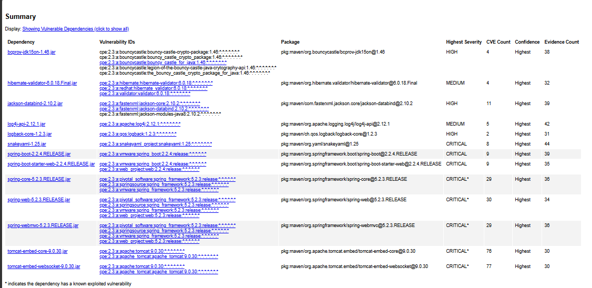
# | Dependency / Package | CVE Codes Found | Required Remediation Version
1 | bcprov-jdk15on-1.46.jar | CVE-2016-1000338, CVE-2020-15522, CVE-2023-33202, CVE-2015-7940 | 1.73 or higher
2 | hibernate-validator-6.0.18.Final.jar | CVE-2025-15104, CVE-2025-35036, CVE-2023-1932, CVE-2020-10693 | 6.2.0 (or 7.0.0) or higher
3 | jackson-databind-2.10.2.jar | CVE-2026-54512, CVE-2026-54513, CVE-2020-25649, CVE-2020-36518, CVE-2021-46877, CVE-2022-42003, CVE-2022-42004, CVE-2026-50193, CVE-2026-54514, CVE-2026-54515, CVE-2023-35116 | 2.18.9, 2.21.5, or 3.1.4 or higher
4 | log4j-api-2.12.1.jar | CVE-2026-34479, CVE-2026-34480, CVE-2025-68161, CVE-2026-34477, CVE-2020-9488 | 2.25.4 or higher
5 | logback-core-1.2.3.jar | CVE-2023-6378, CVE-2021-42550 | 1.2.13, 1.3.12, or 1.4.12 or higher
6 | snakeyaml-1.25.jar | CVE-2022-1471, CVE-2017-18640, CVE-2022-25857, CVE-2022-38749, CVE-2022-38751, CVE-2022-38752, CVE-2022-41854, CVE-2022-38750 | 2.0 or higher
7 | spring-boot-2.2.4.RELEASE.jar | CVE-2023-20873, CVE-2026-22733, CVE-2022-27772, CVE-2023-20883, CVE-2026-40972, CVE-2026-40975, CVE-2026-40973, CVE-2026-40977, CVE-2026-41001 | 2.7.34, 3.3.20, 3.4.17, or 4.0.6.1 or higher
8 | spring-boot-starter-web-2.2.4.RELEASE.jar | (Inherits same platform CVEs as Spring Boot above) | See above (Upgrade parent Spring Boot version)
9 | spring-core-5.2.3.RELEASE.jar | CVE-2022-22965, CVE-2026-47884, CVE-2026-47891, CVE-2026-59283, CVE-2024-22259, CVE-2021-22118, CVE-2026-47886, CVE-2026-47888, CVE-2026-47893, CVE-2026-59282, CVE-2020-5421, CVE-2022-22950, CVE-2022-22971, CVE-2023-20861, CVE-2023-20863, CVE-2026-22740, CVE-2026-47887, CVE-2026-59281, CVE-2026-22737, CVE-2022-22968, CVE-2022-22970, CVE-2026-22745, CVE-2021-22060, CVE-2021-22096, CVE-2026-59280, CVE-2026-41839, CVE-2026-59314, CVE-2026-22741, CVE-2026-22735 | 5.2.26, 5.3.50, 6.0.31, 6.1.29, 6.2.20, or 7.0.8.1 or higher
10 | spring-web-5.2.3.RELEASE.jar | CVE-2016-1000027 (Plus general framework CVEs listed in row 9) | 6.0.0 or higher (or see row 9 framework patch versions)
11 | spring-webmvc-5.2.3.RELEASE.jar | (Shares framework CVEs listed in row 9) | See row 9 framework patch versions
12 | tomcat-embed-core-9.0.30.jar | CVE-2020-1938, CVE-2024-50379, CVE-2024-52316, CVE-2024-56337, CVE-2025-24813, CVE-2025-31651, CVE-2026-41293, CVE-2026-43512, CVE-2026-65905, CVE-2025-66614, CVE-2026-43515, CVE-2026-55276, CVE-2026-59083, CVE-2026-59084, CVE-2026-65182, CVE-2026-68525, CVE-2025-49124, CVE-2026-66422, CVE-2026-68569, CVE-2020-11996, CVE-2020-13934, CVE-2020-13935, CVE-2020-17527, CVE-2021-25122, CVE-2021-41079, CVE-2022-29885, CVE-2022-42252, CVE-2023-44487 | 9.0.121, 10.1.58, or 11.0.25 or higher
13 | tomcat-embed-websocket-9.0.30.jar | (Shares the embedded Tomcat CVE core listed in row 12) | See row 12 Tomcat patch versions

5. Mitigation Plan
Interpret the results from the manual review and static testing report. Then identify the steps to mitigate the identified security vulnerabilities for Artemis Financial’s software application.

The vulnerability assessment shows us flaws in both the custom source-code (Manual Review) and in the dependencies (Static Testing).

Manual Review:
The application contains architectural and code level design flaws. The lack of encryption, user authentication and insufficient input validation leaves this application vulnerable to any number of attacks.

Static Review:
The Maven Dependency Check indicates that Artemis Financial relies on out of date open source libraries. Many High/Critical CVE’s affect frameworks like SnakeYAML, Hibernate Validator, Apache Tomcat, and BouncyCastle.

The best way to secure the RESTful web API is to implement sequential code configurations and structural practices.

- Open the pom.xml file and upgrade all dependency blocks to modern stable releases to remove the CVE’s in SnakeYAML, Hibernate Validator, and BouncyCastle.

- Configure the server properties to accept inbound packets using a secure communication protocol, like HTTPS or TLS.

- Start to utilize modern cryptography standards, like SHA-256 to verify file integrity.

- Restructure the inputs so they use validation techniques to prevent injection attacks.

- Implement an identity validation system, so that the various elements of CRUD is not accessible by any user.

- Change the DevOps pipeline into a DevSecOps pipeline by including the Maven dependency check in the build definition file.

